Labor Day Lighthouse 5K-NEED TO KNOW INFO.
Is this your first race? First time joining Barrier Island Group?
WELCOME ALL to the Barrier Island Group running family!
SCHEDULE OF EVENTS
Sunday 9/6:
2-4 pm: Packet Pick up at Lighthouse Sports Bar & Grill in Buxton
Monday 9/7:
6:30-7:00am: Late packet pick-up (no race day registration)
6:45 am: Announcements
7:30: Race Start
8:30: Post-race gather & awards (approximate) This is a chip-timed event.
(Note: we will be giving awards for the 1st/2nd/3rd place overall Male & Female race winners as well as one deep (1st place) in each age group category).

COURSE
- This is an out & back course. There are 2 places at which you must cross Lighthouse Rd. USE CAUTION!
- There is a water stop set up on both sides of Lighthouse Rd. (British Cemetery) at which you can stop each way.

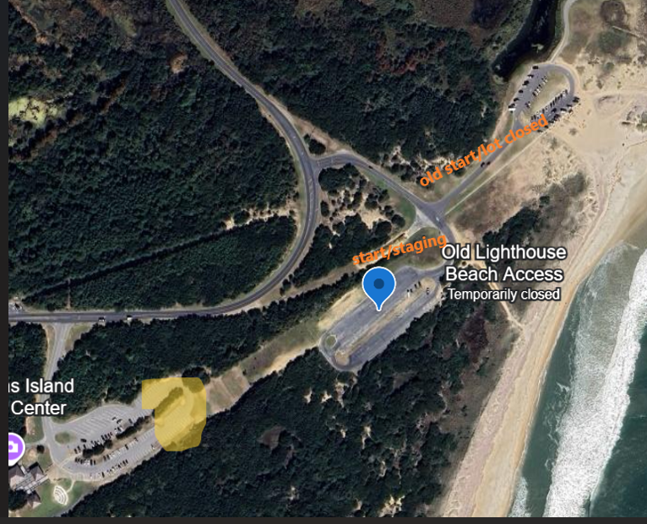

PARKING:
Follow Lighthouse Rd. into the park and take the first left to Old Lighthouse Beach. Parking is available in the lot on the right witch is also the start/finish area. When this lot is full, it will be coned off and overflow will be at the 2nd left off Lighthouse Rd, to Cape Hatteras Lighthouse, you will have to walk along the multi-use path to the upper lot to the start.

